NOVAWE BOARD MEETING – Minutes
--------------------------------------------------------------------------------------------------------------------
Meeting by Google Meet Conference Call
Board of Directors
Present: Laura Guillaudeu, Biddie Lowry, Stephanie Jennings, Mills Smith, Nancy Wilochka

December 20, 2022 / 7:30 pm

Meeting called to order at: 7:30

Old Business
- Motion to approve minutes from Nov 14, 2022 meeting by Biddie Lowry.
- Stephanie- Does LCEA have a date yet for Expo? Likely in April. Frying Pan’s Equine Expo is April 15.
- Member Meeting – January 25th:
  - Power Point of Meeting –first draft is finished. Suggestion made for Stephanie to run the Zoom and take questions in chat. We need to do a big push for membership to sign up for the meetings, after the holidays.
  - Awards Presentation will be:
    - Highest Dressage Score
    - Joseph Klosek Memorial Trophy – Kim Ellis will get a summary of background of trophy to Biddie. Kim will have a smaller trophy engraved for recipient, and also have the person’s name on the larger trophy.
    - Do we want to do a Volunteer of the Year Award? Yes, Mills will look over volunteer lists and choose 3 so the board can vote on it at January meeting.

New Business
1. President Report – Biddie
- Propose purchase of 6 more pole bases from High Country (Amazon -$248) and poles from local box store. We can also get a quote from ATT.
  - Discussion: General consensus is that we can’t have too many poles. Motion made to purchase 6 more poles and bases. Biddie will purchase.

2. Membership Report –Laura:
a. Member count: 27 renews, one business member. We will keep people active until Jan 31, after that date they come off roster.

3. Treasurer Report – Biddie
- Upcoming Expenses – Approval needed to order ribbons for Licensed Shows (2) and the Schooling Show (1).
- Financial Summary:
- Cash on hand: $8742.90
- Forecasted balance: $8688.69

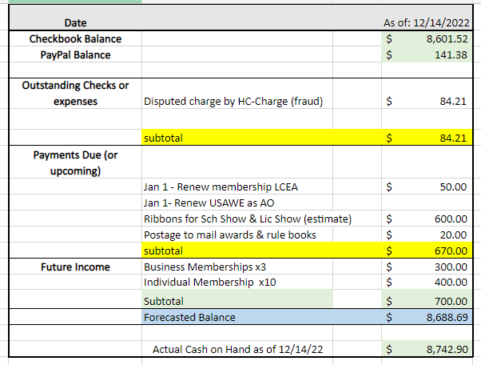

4. Events Report – Biddie
- March Clinic – Mills Smith will be the clinician, Venue to be determined. Biddie spoke with Wanda Flanagan and she has to check with her family to hold it at her farm in Waterford at Hampton Hills. The Tri-State obstacles are located there and it is a strong possibility.
- April – Licensed Show – Suggestion to ask for a ribbon sponsor to help defray costs of ribbons, offer space on show bill, banner at event, announcement. For both shows at 3 Bulls, they had sponsors that gave cash but then never mentioned who they were. Or, have obstacle sponsors. Cash prizes are good too. We need someone who can gather sponsorships. Motion made and passed to spend up to $600 for the ribbon purchases.
  - Next step is to form the Show Committee. Show Committee is made up of Event Organizer, Show Secretary, Show Manager, Stable Manager, Hospitality, Awards & Banner Coordinator: Stephanie will be Show Secretary and Stable Manager, and Lyndsey Moritz will be paddock steward on first day. Biddie has some names to reach out to people to help out. Biddie applied for a license with USAWE for both shows. Main job for the show manager is gathering the volunteers and managing show and staff. Biddie will put Google form together for entries.
- Schooling Show or Out of Town Clinician – Region 6 & &7 Organizers and AOs have created a calendar of events. The calendar is getting full. We had mentioned the third week of June would be our next event. Biddie has a conflict – possibly 3 weeks in June are out for her. Propose that we have a schooling show instead of an “Out of Town” Clinician at this time, either May 27-28th or June 10th -11th. Table discussion until next meeting.

7. Any other business or concerns? no

Meeting adjourned at: 8:25 p.m.

